**Bondage mod ideas for Minecraft**

**Outdated Table of Contents:**

Bondage mod ideas for Minecraft 1

Table of Contents: 1

Introduction 1

Death and K.O. system complete gameplay rework 2

NPC trap block 2

Custom Bondage position block 2

Bondage furniture 3

Struggle system and tying system 3

Hurt if loose minigame 4

NPC roles 4

Gag levels 7

Different bondage poses affect movement gameplay 8

Retying block or robot/npc for retying? 8

Collar to keep slave close 8

Disable collars? Make collars only appear for owners and not others? 9

Levels of different restraints 9

Other benefits that new mod can have over previous version 10

**Introduction**

This document is made by CreatorGalaxy (Also known as ElinaAvel and DRCrG). The goal of this document is to represent all of my existing ideas of possible bondage mod for minecraft, so that developers can have good inspiration to make this great mod come to life. Some parts may be written poorly, sorry and feel free to contact CreatorGalaxy (me) on discord for further explanations. I hope this will help you get a better view on possible bondage mod gameplay and you will use some of these ideas to make a great mod which I would love to play myself too in the future. With that out of the way, let's begin.

**Death and K.O. system complete gameplay rework**

Idea: Instead of a vanilla death system when on losing 20 hp you die, here you should lose consciousness. While lost consciousness, you have additional 10 hp, if another player attacks and brings it to 0 hp, this leads to actual death. If no one kills player (creatures don’t attack K.O.’d players), player can lie for a minute in K.O.’d state, until player is given chance to either respawn and drop all items on ground (or left in his dead body as a temp chest entity), or get up(?) or wait for help from other players.

In case someone finds K.O.’d player, he can also tie him. This “awakes” player and gives him 10 hp back, but he will be tied in the restraints, chosen by either player or NPC.

Logic: this makes the game less stressful and gives another, more fun punishment for losing all hearts, actually bringing bondage mechanics much closer to gameplay. Some NPCs can attack players and upon their K.O. capture them for their own “goals”.

The player only dies if he loses all 20 hp and 10 hp of K.O. This can only happen if the player will fall into the void or in lava. It can be also changed by making lava monsters which will tie player when he dies in lava (or he gets trapped in obsidian bondage) and with adding some void creatures, which tie player in void and return on surface, but tied. Alternatively death in lava can teleport players in a trap block.

**Alternative KO’d idea**

Player can actually die as in vanilla, the difference in second idea will only be that the menu of respawn will appear as in vanilla, but the player will leave its body lying as an entity and anyone who will tie it will “resurrect” the player. So no KO’d hearts mechanic will be needed. (KO’d hearts originally were intended for moments when other players don’t want the current player being resurrected in a chosen region, that’s why they could just “kill the body” and go in vanilla way).

**NPC trap block**

Idea: This is a block which can be placed by player or will spawn automatically (ideally) in vanilla structures. This block is used as a place for NPCs, who captured players, to leave in. These will be static bondage places, for spiders – big webs, for slimes – some slime wall things, for blazers – chains for walls, etc. Alternatively NPC can teleport all players to specific bondage locations for players to take or just spread their coordinates in chat just like in kidnap rp mod. NPC trap block isn’t working like tied to a fence and instead makes the player use a specific pose.

**Custom Bondage position block**

Idea: This block is transparent, and only is visible while carrying a tied person (on lead) or while holding specifical item. On right click it opens the menu like in NPC minecraft mod. In this menu the player has sliders for position of the doll – x,y,z position, leg, arm rotations in all axes, leg and arm bendings, body bendings.

Logic: This feature will allow players to make their own new poses. This will be perfect for anything that mod won’t add in game.

**Bondage furniture**

Idea: Mod can include some bondage furniture, alternatively to “custom bondage block”. In case players won’t have chisels mod they will still be able to have simple furniture. This idea may have bad consequences though, if players will place too much furniture or won’t use it as intended.

**Struggle system and tying system**

Some binds (or all of them) are applied in 5 stages. Mod should add a new item - throwable slimeballs, which would be crafted in amounts of 5-8(?) from slimeball. In the case of slime balls, every thrown slime ball every time applies 1/5 of the stages. Stages don’t disappear and stay on the player, until the player presses “G”. In case stages aren’t filled 5/5, restraints are easily struggled from. Every 1/5 of the stage makes the player move slower, deal less damage and mine slower. In case all 5/5 stages are applied, the player becomes “tied”. In this case all restraint durability is applied and the player goes in a state of “tied”.

In case of slimes and skeletons - every first attack has a small chance of applying any bondage, but every successful attack must make all other attacks more successful. So ⅕ will work in 10%, ⅖ will be 50% and ⅗, ⅘ and 5/5 will all work 90-100%, gradually making player more and more helpless from escaping.

Logic: this way “bondage PVP” will be more intense since players will have to not only throw slimeballs or restraints at each other, but also press “G” in time, which also makes gameplay better.

Throwable restraints are depletable, not throwable ones will stay and be used as a tool to apply stages. The last used restraint to apply 5/5 will be taken as the main restraint for the player and will disappear from the attacker's inventory after usage.

Tying arrows (if they even should be added) should also work in at least 3 stages (or alternatively they can deliver all 5 stages, but gradually, like a poison, leaving some time to press G)?

Suggested restraint struggle minigame:

1) Press G

2) Game shows arrows on screen somewhere (ASDW) - up, down, left or right.

3) You should press as fast, which arrow is shown. If you press fast and right - you get a significant struggle amount, if you press wrong, you can even tie yourself more. (If A showed and you press D – it ties your character a bit more, if S is showed but you press A or D – it has no effect, only opposite keys have effect)

4) While you're pressing movement arrows and holding G, you're not moving, your character should shake a bit in the direction of your pressing, making cute struggle animation

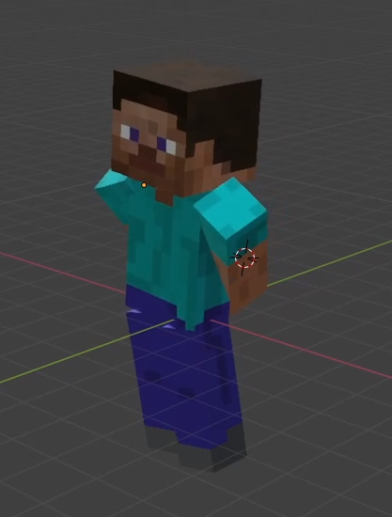

5) It also can have block breaking effect on character like pieces of it falling on ground when you succeed with struggle

6) If you use tool – you hold tool in hand and press G, block breaking effect is constant and it makes sound - everyone nearby can hear it

Logic: This is simple and yet can work better than just one click, has winning and losing conditions.

Note: Self-tying should also have some cap, players should not be able to go infinite self tying (probably?).

If only legs are tied – a player can’t untie himself fast, he should also use tools.

**Get hurt if loose struggle minigame**

Idea: Some restraints may hurt players if they lose minigame? Or do other actions, maybe giving their coordinates in chat? Paralyze? Tie even more?

**NPC roles**

Idea: There should be NPCs in the wild, which will tie players. Not like in kidnap mod, this should not add only new mobs like kidnappers and damsels. Instead this mod can add tying abilities to existing mobs and add only locational and only necessary mobs.

To make it less annoying, I highly advise adding good tying possibilities ONLY to biome specific mobs or location mobs. So mainly no skeletons, zombies, spiders, since they can spawn anywhere and not at all predictable – this is bad because this means that players can be randomly tied everywhere, as with kidnappers in KRP. This is not very fun since it has no predictable gameplay and is similar to creeper mechanics. Yet, zombies and skeletons can tie players in 1-5% cases, or in case they went in K.O. Also skeletons can throw arrows, which in only 5% cases will throw 10 struggle chains on the player or only 1/5 bar tying, which the player can easily get rid of by just pressing G at the right time. Otherwise other arrows will quickly increase the level of tying to 2/5, 3/5 and end up tying the player completely.

Full list of NPCs with their skills:

**Value** – my old subjective rating of how important it is to add

**Name** – name of NPC

**Capture?** – if mob can be tied like a normal player. These mobs usually have similar player animations so probably they can be captured. This means, they can work as damsels in KRP with probably similar mechanics. Other mobs or NPCs can be caged, somehow? Then made into pets…?

**Tying?**  – type of behavior, which creature can use to bondage-attack player:

* **KIDNAP** – Full functionality of kidnappers, NPC is attacking to tie and bring with them for some goals. Can use any means to tie player – either K.O. him and then tie or tie in the process of attacking. These NPCs are usually the only kidnap species for the chosen world.
* **Attack** – main attack of mob or NPC is also tying players gradually.
* **KO** – Automatically ties K.O.’d player after attack, if the player attacked first, only as self-defense.
* **SCAvenger** – NPC only tries to kidnap already K.O.’d players and not attack them for that goal. Can take such players with them to “Npc trap block”.
* **No** – can’t tie.

Green – Main world, Yellow – desert, White – tundra, Cyan – water, Gray – caves, Red – Nether fortress (orange – just neither), Pink – end.

Reason – short reason why this creature can be added according to minecraft overall gameplay:

* **Passive** – it won’t be hostile so nothing to worry about;
* **Rare** – it is rare so nothing to worry about;
* **Loc** – this creature only lives in specific locations and won’t bother you until you travel far;
* **Biome** – this creature only spawns in specific biomes – you have to travel to it to get in actual danger.
* **!!!** – this creature spawns everywhere, means its most dangerous and unpredictable (this is counterreason, the reason it may be added is in adding at least some randomisation to the game, but can be ignored);

| Value | Name | Kidnappable? | Tying? | % | Reason | Description |
| --- | --- | --- | --- | --- | --- | --- |
| +++ | Villager, Neko, Creeper girl | Yes! | No | 100 | Passive | Similar to damsels from KRP, they spawn in villages, breed as villagers, with villagers mechanics, and have girls with player proportions. |
| ++ | Illager people | Yes! | **KIDNAP** | 50 | !!! | May look like a player too. Spawn near Illagers. Bring player to trap blocks in vanilla Illager towers (or admin placed trap NPC blocks) |
| ++ | Witch | Yes! | Scavenger | 50 | Rare | Make them look more like players too. |
| ++ | Zombie | Yes! | Scavenger | 12 | !!! | Zombieapocalypse, zombies can carry K.O. players in hands for any reason and leave them randomly in random places, just like endermans with blocks. |
| ++ | Skeleton | Yes? | On Attack | 10 | !!! | Sometimes can tie legs with chains with special arrows. (maybe full bondage?) |
| ++ | Iron Golem | No | On KO | 100 | Loc | Ties in chains or metal, players who attacked them, on their KO. Fair and less painful. (can have retying work mechanic?) |
| ++ | Zombie Mummified | Yes? | On Attack | 35 | Biome | For those who love Egyptian themes. Mummifies. |
| ++ | Temple Guardian | Caged | On KO | 100 | Loc | Makes temple raids harder. |
| ++ | Siren/Squid-girl | Yes! | On KO | 50 | Biome | Makes Drowned more interesting, adds cool new species. (Mob-only specific bondage that lets you breathe underwater??) |
| +++ | Slimes | Caged | On Attack | 75 | Biome, Loc | Slimes can capture players inside of them, this will make player ride slime inside of it while restrained. |
| +++ | Cave Spiders | Caged | On Attack | 75 | Loc | Ideal local mob for capturing players. They will tie the player in the web until the player is captured, then bring the player to “trap block” or alternatively to spawner block and tie to it. |
| ++ | Warden | No | On KO | 75? | Loc | Will work somewhat close to Iron Golem |
| ++ | Snow Skeletons | Yes? | On Attack | 30 | Biome | Ties with ice? Makes snow biome snowier |
|  |  |  |  |  |  |  |
| +++ | Piglins | Yes? | **KIDNAP** | 70 | !!! | Will kidnap players and make them mine nearby gold. Will only attack people without gold as usual. |
| +++ | Demonesses | Yes! | On Attack |  | Loc | Can be in fortresses. Everyone likes Demon girls? |
| ++ | Blazes | Caged | On KO |  | Loc | Local mob, ideal for kidnap feature. Can tie with magic chains and make the player float up to the ceiling? |
| ++ | Magma Slimes | Caged | On Attack |  | Biome | Make players trapped in concrete? Regular slime mechanics? |
|  |  |  |  |  |  |  |
| +++ | Endergirl | Yes! | **KIDNAP** |  | !!! | Girl with violet hair, appears randomly in the end dimension as an alternative to kidnappers. |
| ++ | Shulker | Caged | On Attack |  | Loc | Throw kidnap chains, make end cities harder. These chains don’t let players fly. |
| ++ | Enderman | Caged | On KO |  | Rare | Only use chains or hold players (make players ride them) if they are attacked by them and were defeated by them. |
| + | End Dragon | No | On Attack |  | Loc | Makes dragon attack harder. Probably also uses chains. |
|  |  |  |  |  |  |  |
| ++ | Teeths in block | Mined | On KO |  | !!! | Can rarely appear in end dimension, deal damage to player and capture on KO |
| ++ | Loose sand | Bucket/ Mined | On KO? |  | Loc | This block is placed by the player. Not sure what it does, but maybe player can accidently fall inside where traps are. |
| ? | Loose snow | Bucket | On KO? |  | Loc | Ties with ice instead of killing, makes move very slow. |
| ? | End Wizard | Yes! | **KIDNAP** |  | !!! | Another type of main end kidnapper? |
| ? | Robot of end city | No? | **KIDNAP** |  | Loc | Makes End Cities harder. May add robot tying feature. |
| ? | VOID | No | On KO |  | !!! | Bondaged on KO to void. Helps not lose items and “recover” from fall, keeping punishment – losing time while struggling to chains of void (or any other magic). Also this restraint makes the player fly up until the player touches any ground (or as horus fruit). |
| ? | Wither skeletons | Yes? | On KO |  | Loc | Good locational mob |
| ? | Elite Piglins | Yes? | On KO |  | Loc | Good locational mob. Can tie with neither restraints, could be farmed for neither restraints. |
| ? | Poor piglins? | Yes? | Scavenger |  | !!! | ? |
| ? | Neither People | Yes? | ? |  | !!! | People of neither? |
| ? | Illusioner | No? | On Attack |  | Loc | Very very locational mob |
| ? | Monkey or amazon kidnappers? | Caged | ? |  | Biome | Possible idea of adding lorefriendly kidnappers in a jungle biome. |
| ? | Giant Frog Kidnappers | No | On Attack |  | Loc | KonoSuba reference – frog that eats player but releases him on getting damage. |

This should make mod contact very well with already existing gameplay and will make new “punishment” for every existing action in game. This is what KRP lacked the most in my opinion.

Only NPC, which were used in “rp” with players, can have a state where they “can’t despawn” naturally. This will keep player’s slaves and kidnappers in game as long as they play.

**Gag levels**

Idea: Different gags can do different effect on player text:

1. Ring gag allows only vowels – a,o,u,e,I and etc (no y) (additionally h, g?).
2. Light gag allows only consonants and some vowels, they restrict talk only a bit
3. Regular gag allows only some consonants (similar to Kidnap rp)
4. Big gag rarely allows any consonants, others will just be “-“, also can have m, h, g.

**No permaties**

In KRP mod its easy to make permatie - just place dispenser, on observer triggering it will automatically place trap to trap player infinitely. This is a bit boring and requires admin work in case of abuse, not adding that much fun (probably?). This is why these types of restraints should be placed in game with caution. Gameplay should be more dynamic, struggle should have different gameplay and not become tedious and grindy. This can be fixed by either not adding traps or by not making them spawn with a dispenser. Or traps can automatically break if they spawn directly under the player.

**Different bondage poses affect movement gameplay**

1) Untied legs let you walk freely (but may restrain just arms)

2) A bit tied legs like chains make you slower or split jump height (legs can be tied separately from arms too, this makes slave shackles)

3) Simply tied legs restrain movement as in Yuti's mod - you can jump.

4) Hogtie makes the character slow and A, D works weird (but probably can jump on blocks?)

5) Kneeling makes the same effect but no A,D mechanic(?)

5.1) Dog/cat tie makes walking on arms and legs...?

6) Mummified - if a player is tied, placed on ground, he can't stand, only A,D walking works, as rolling (W and S may be working slower?)

**Retying block or robot/npc for retying?**

This block can work as an admin block or for any players. It can have some logic, like, activated on redstone it will give player specific bondage, or it can do other logic – the point is that its untying player (if player has specific bondage) and ties to others. This way you can make redstone logic so that slave can mine, then “retie” himself to get another tool or another task and never let them fully free from chains, so that they always play a bit restricted. This may be fun…?

The retying block may also just change existing ropes rules a bit, like removing restraints from arms or legs, removing specific parts of restraint like gags, blindfolds and earplugs etc. Kidnappers, enslaved mobs or iron golems can have same mechanic.

**Collar to keep slave close**

Collar or gear, which will automatically shock the player, if he goes beyond some distance from its owner or from a placed controlled block. Can set up maximum and minimum distance. Other distances will shock and KO the player or kill.

**Disable collars? Make collars only appear for owners and not others? (outdated)**

I’ve experienced a couple of sad situations where collars lead to sadness, when someone can’t own someone. I think this is the good reason to not add collars at all or to think how their mechanic can work differently. I think collars just should not represent ownership of a player by some other player. So that it becomes fair for everyone. Collars are bad, don’t add!!! D: (Claiming NPCs is okay though, I guess?)

EDIT: Collars probably should still not have any ownership labels in chat. I don’t mind the item itself, it's good. And owners can have enough expressiveness in its texture. Labels, though, should really lead this to a weird way, I’m afraid.

**Levels of different restraints**

Different restraints may have different resistance. If you use the right tool on right restraint – you can escape faster. This adds strategy to the game. Everyone usually have shears and swords on them, so they give an easy and convenient way of escaping. Swords may be broken faster this way(?) as an additional punishment. Knife and Rasp are more “elite” types of escaping.

Rasp should only work on metal restraints, it is a rare way of escaping for rarer occasions. Possible craft:

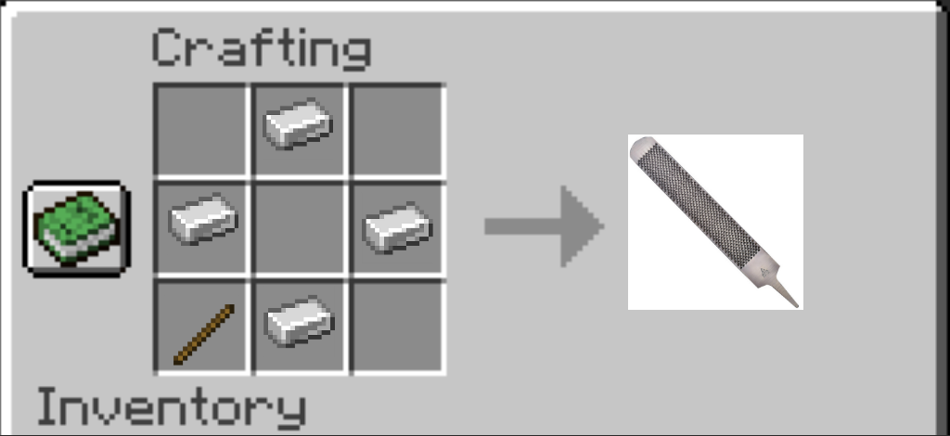

Here are some “multiplications” ideas at using G when holding right tool:

Rope lvl 1 - Shears 10, Knife 5, Rasp 1

Web lvl 1 - Shears 10, Knife 10, Rasp 1

Slime lvl 1 - Knife 5, Shears 2, Rasp 1

Leather lvl 2 - Shears 5, Knife 10, Rasp 1

Rubber lvl 2 - Shears 3, Knife 3, Rasp 10

Chains, metal lvl 3 - Knife 1, Shears 1, Rasp 10

Magic lvl 3 - Shears 3, Knife 3, Rasp 3

Swords always have a 10x multiplier on restraints, equipped by mobs, like web or slime (probably?)

**Other benefits that new mod can have over previous version**

This info can be a bit outdated since I only played with this mod 1 year ago or more and I don’t know if anything of this was made. This is an old list of what I wanted KRP to have and what it didn’t have, what I wanted to make for my own mod.

| Important? | Feature | Kidnapmod already have? |
| --- | --- | --- |
| +++ | New MC version | No |
| +++ | Can tie, gag, etc | Yes |
| +++ | Can comment your actions | Yes |
| +++ | Can tie player to block, place, pose | Kind of, mostly no |
| +++ | Can hold player in hands or carry | No |
| +++ | Can lead | Yes |
| ++ | Kidnapper jobs? | Can if enslave |
| ? | Traps? | Yes |
| +++ | Bondage poses? | 3 |
| +++ | More bondage types? | A lot! |
| ++ | Whip? | Yes |
| +++ | Custom textures? | Yes |
| +++ | Different poses? Like hogtie? Lying? | Kind of, mostly no |
| ++ | Mobs can tie? | Only kidnappers but yes |
| ++ | Can work while tied as a slave? | No, only collars |
| ++ | Can walk and run while tied? | Not yet? |
| + | Can change bondage while tied? Retying machine/block/robot/npc? | No |
| + | Can unequip gag while tied, with some mechanic? Can be untied without gag falling off? | Kind of, mostly no |
| + | Can equip lead while tied? Can lead yourself to something? Can get into a restricted place by yourself without any help from others? | Kind of, mostly no (possible with kidnappers) |
| + | Can enable/disable picking up items for bondage? Other bondage settings? Using items? Being able to attack? Using commands? Setting up bondage suit logic in any way? | No |
| ++ | Can wild kidnappers place players in restricted poses? | No |
| ++ | Can shock players from a distance? | Yes |
| +++ | Kidnappers spawn in specific locations? | No |
| + | Can place players in chests? (block?) | Already can? |
| ++ | Custom texture for armor? | No |
| + | Kidnapped with using Chloroform? | Yes |
| + | Kidnap on bed? | Yes |
| + | Hug tied player? | Kind of, mostly no |
| ? | Sex with a tied player? | Ehhhh…??? No???? |

**Lead group of slaves, sit on chairs?**

KRP was allowing to lead players while tied, but it wasn’t allowed to lead tied player who lead another player and so on. Maybe master can make other players lead each other. Same for sitting on animals or in chairs while tied, crouching while under the hatch. (vanilla is allowing to carry another player pig with lead)

**Pressing buttons with head, using chests?**

Alright, players can’t use buttons far away since hands are tied, but what about head? Maybe player can press a button which is in the same block as the player head? Maybe activating a button this way will actually require player to physically “nod” his head in game? And if the button is 3 blocks high, you have to jump while nodding. This will make some unescapable scenarios more “escapable” while not losing realism too much.

Interacting with chests could possibly give player random item, or he can press right click with item on chest to place it inside.

What about opening wooden doors? Maybe it will work with random percentage with 15% of successfully opening door, while standing close to it?

**Lying knives?**

Mod can add blocks, looking like knives, which can be placed on the floor and equipped when needed the most by right click. (Probably this feature can work with frames too)

**Changing slave walking pose?**

Pose of tied player (sitting, walking, jumping, pose of arms and hogtie) can be adjusted by menu when right clicking on the player. It also can have option to carry a player (this makes the player ride you with a custom pose?).

**Workbench struggle?**

Workbenches can untie player by right clicking? This is a bit overpowered since workbenches can be anywhere, but if it won’t be instant and you have to hold G and press right click to untie yourself faster than regular struggle, that can be “balanced”.

**Less messages in chat**

Chat messages can be good for debugging, I guess, but they should be gone in the release (yeah might be an obvious one, lol, but still). In KRP mod struggle messages cluttered chat too much. Titles can be used instead, but crucial information can stay like messages “you’ve got free”, “you’re tied” and etc.

**Player untying another player always faster?**

I guess it will be actually weird, if you can tie someone fast but to untie you have to spend time, like with current struggle idea. Maybe player untying player should always be as fast as in KRP or not a lot slower? (Or maybe player untying player just struggle tied player 50x times faster?) Or maybe you can lock specific restraints like chains to still make them hard to escape, even with outside help? (Yeah, that can probably lead to bad “/norp” scenarios, but will make it more realistic and will give it interesting gameplay. And come on, isn’t it just a game, where gameplay must always rule, not safety?).

**Norp should be gone?**

The main issue of /norp is that it requires admin work and this means you can’t easily have a full automatic anarchy server with no outside control, which should be possible with vanilla minecraft. I guess that requirement of /norp command can actually say that KRP mod isn’t self sufficient enough in its gameplay and can’t figure out hard situations on its own. This might be an issue, which is why I’d rather try to avoid hard situations in the first place, like not making permatie traps possible at all. This is why I guess that

1. Every restraint must be equally escapable and 10k restraints should be avoided at all costs;
2. There always should be more gameplay escape ways. Like you could use torch to burn restraints, crafting bench, use buttons with head and etc. Yes, this makes restraints less “restraintfull” in some way, but at the same time it gives fun new gameplay to deal with. Restraints become less of a restraint and more like a “new gameplay suit”;
3. Custom bondage position block and npc trap blocks will remove requirement for making permaties, hopefully. There should be an option to struggle of these blocks first(?);
4. Possibility to play while tied. In case all attempts to escape are pointless, there should be at least some ways for player to keep doing stuff in game, maybe restricted and inefficient, but not blocked completely. Even if using simple hoe will take more than an instant.

(this idea might be actually impossible, this is more of a vision of what I would like to be achieved than an actual idea).

**Special abilities**

I really liked how FaaFlax rpd being demon. What if we make it an official feature in a way that every player can get some abilities or personal stats?

The easiest and best way I can see this is that different players could set up different struggle time for themselves. In case they have more struggle time, they can get some benefits from that, maybe as items, like, diamond/netherite/gold/iron/totem valuable reward for being tied for some time, making being tied valuable by itself.

In case players endure everything and don’t use /norp often, they can also get some benefits. There are some players who like harsh rp and this way players will be able to see that easier by checking their status.

Abilities can go much more complex to actually choosing to play as a demon, robot or something else if idea will develop.

**Permaties and high resistant restraints by agreement?**

I guess some people will still want good permaties and good 10k+ restraints. What about making this into sort of an agreement between two people? Maybe there will be a command, which can be sent to a specific player, which will ask “do you want to allow player N to tie you in 10k?” By answering yes, all restraints can be applied on character with more durability than regular. And same or different agreement can disable ability for other players to untie specific player.

Alternatively this can be realized in a way that the player himself should write a command in which he specifies the biggest amount of restraint he can be in, there should be 2 or 3 options: Regular, regular to 10k, regular to insane (millions of resistance?).

**Totem of undying block KO?**

I guess this is their usage now…?

New: Totem of undying should be tied instead of player

**Fixing restraints is not instant.**

Since I’ve already described an idea where even using a knife isn’t instant, strengthening restraints by another player should also not be instant. (Maybe instant things should be avoided even in most other mod mechanics. After all, tying is never done instantly irl.)

**Possible arm poses for mod**

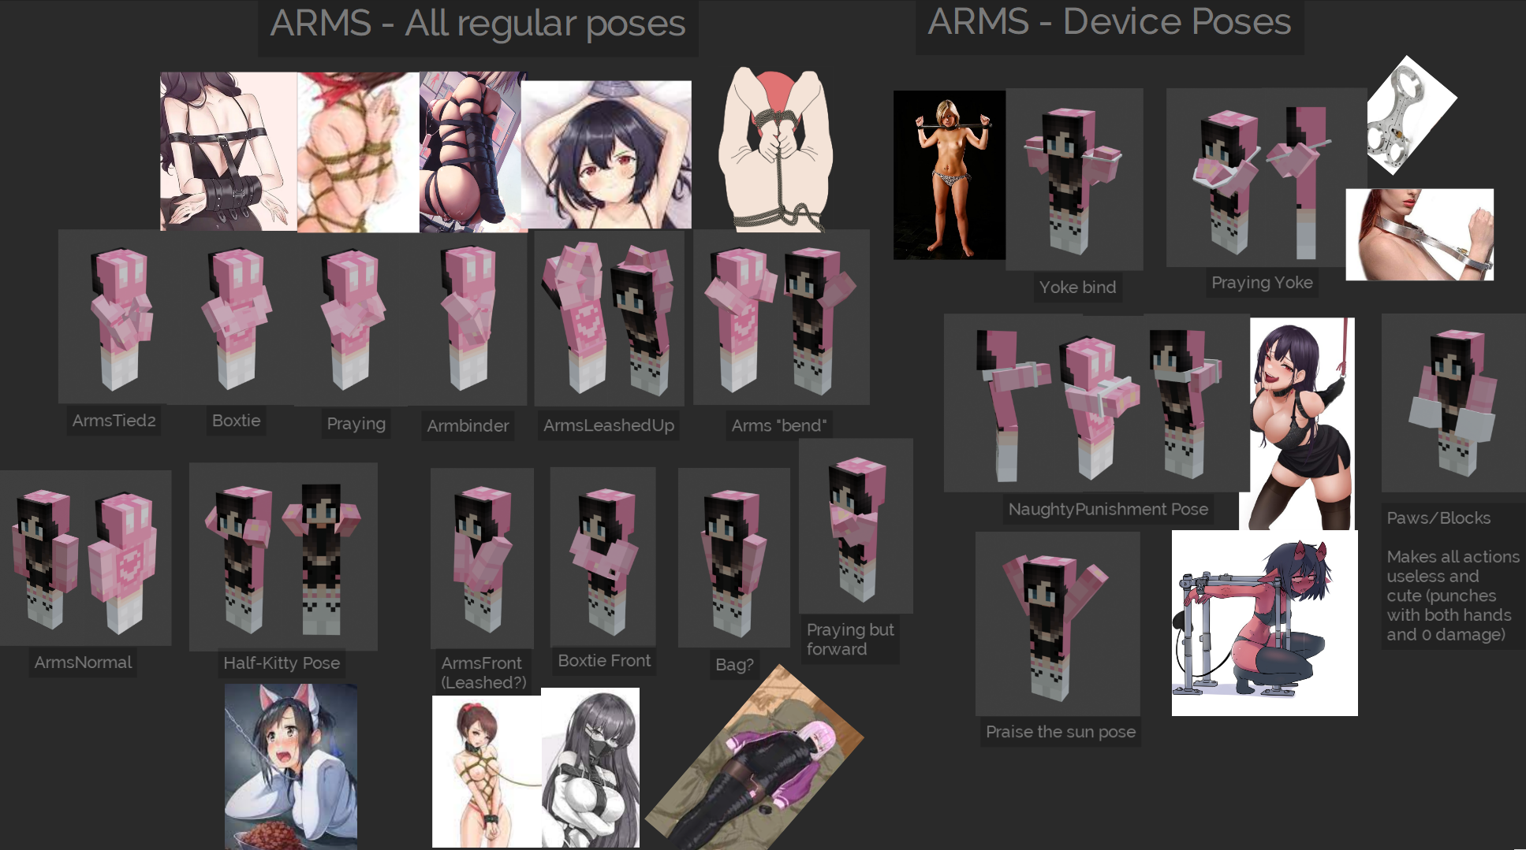

**Changing pose mechanic**

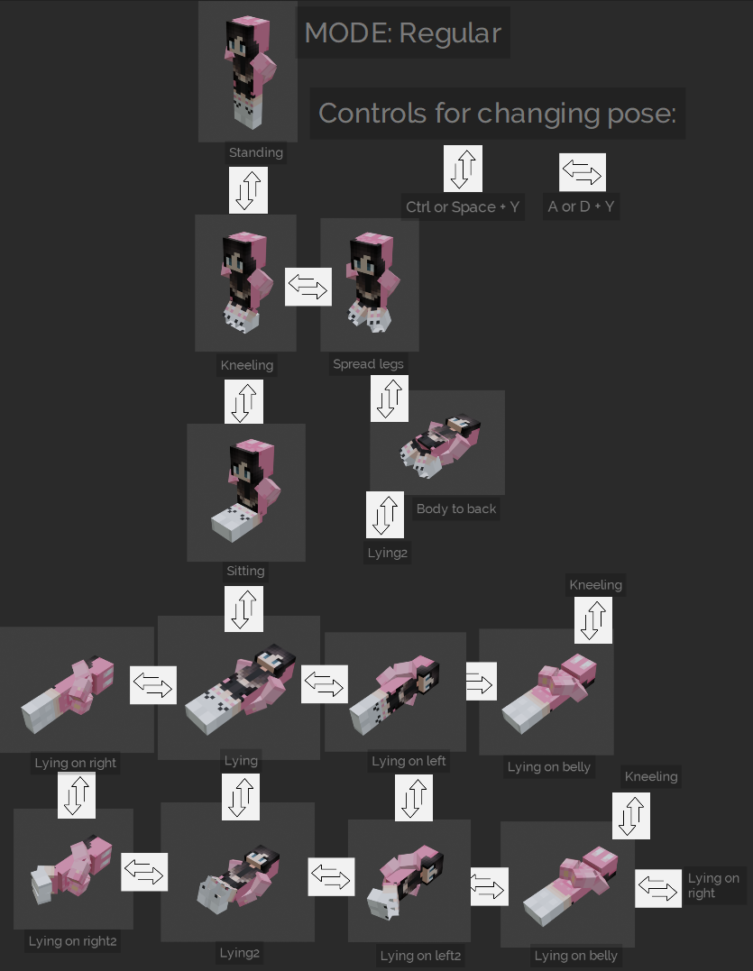

*shift or space

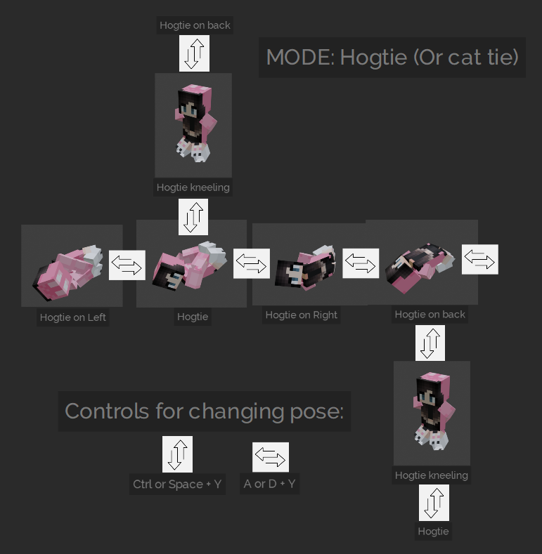

**Possible ingame interface:**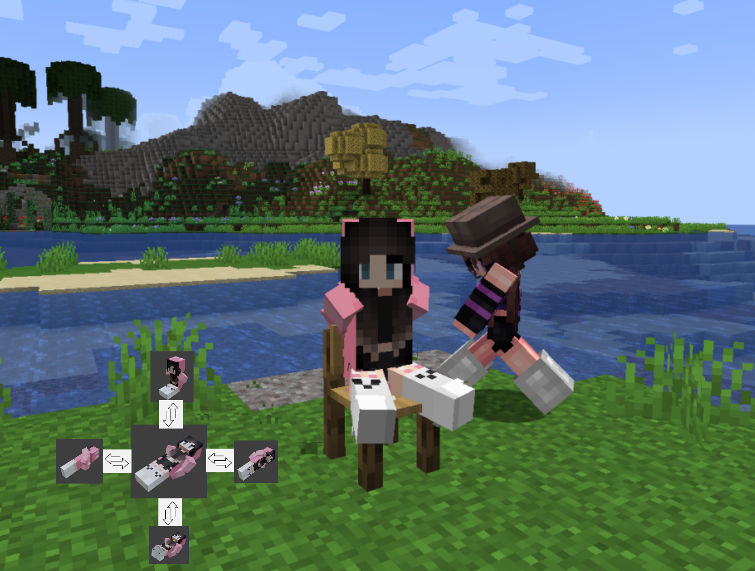

**Use any item with struggle minigames**

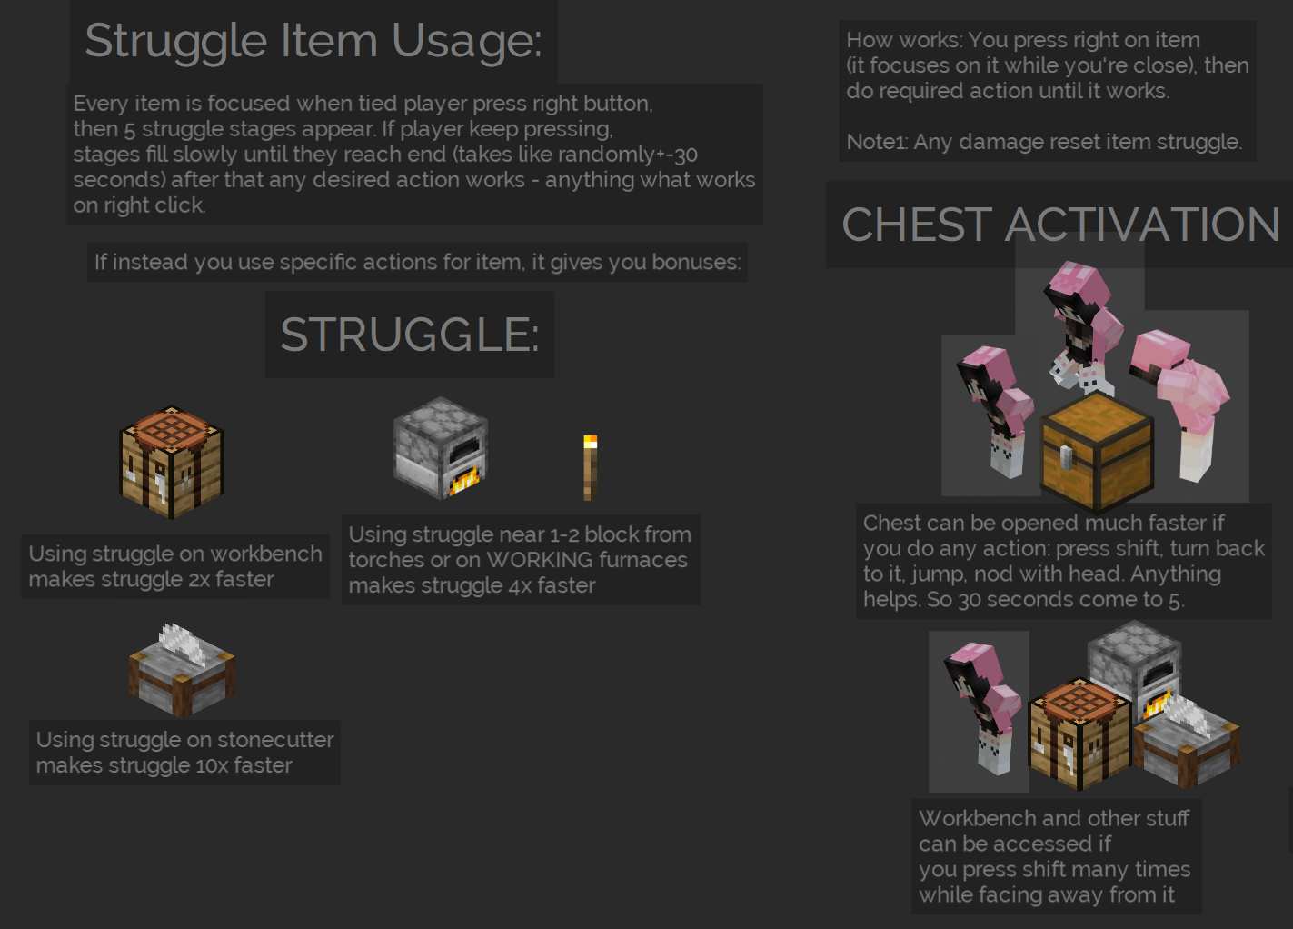

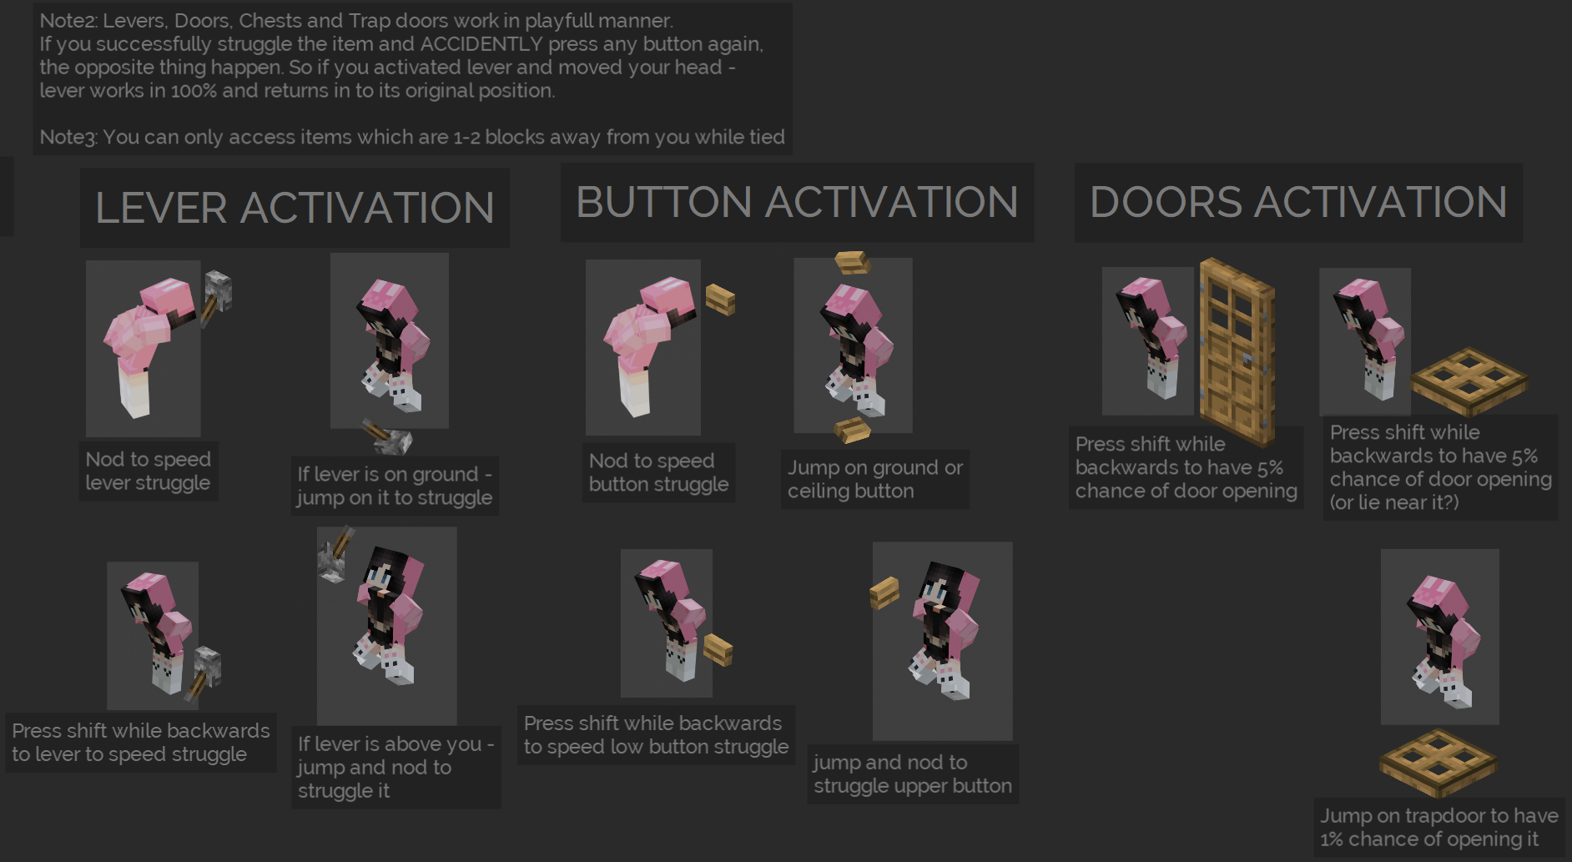

**Stay on server forever**

A mechanic which could be toggled by default or on events which makes an NPC copy of a player after he leaves the server. NPC is copying everything from the player - all tied gear. But there is no way to access its inventory or kill the npc. But you can tie, untie the NPC. In case NPC is actually killed in void, it could respawn somewhere at spawn or just disappear, not affecting Player’s life. Player should also spawn above some block when he enters to avoid the possibility of killing player on enter.

Note: Player spawns where the npc appears on his server entry. On his spawn NPC is despawning and any bondage gear is copied from npc to the character.

**Write on bodies**

Add a separate layer on player skin and edit its pixels with in-game paint mod. Or with texture load. Anyone could edit it while the player is in bondage. Different materials could be added: Markers, scars with different stay time. All tattoos or markings will work better on naked skin.

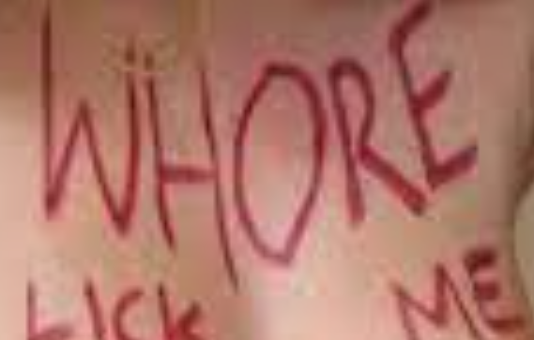

**Shaking effects**

In case there is a way to add additional animated polygons to the character body, there is a possibility to add shaking effects to simulate something, for example struggle or some horny gear.

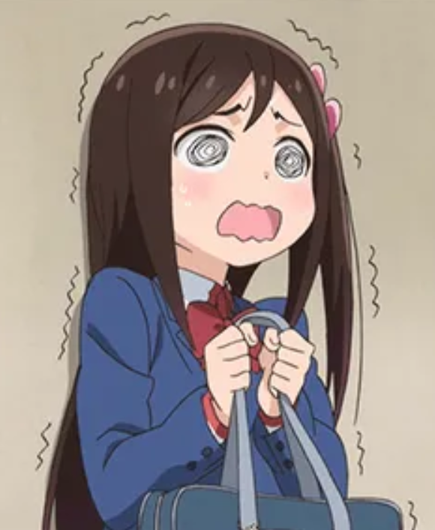

**Commands to apply tool/material stats**

These commands could be added to apply parameters to tools or restraints:

/rn material [priority] [type] [struggle amount]

> Priority - materail layer from 1 to 10 on body.

> Type - material type: anything like wood, rubber, metal, magic, rope and so on.

> Struggle amount - how many numbers will material add to bind. (in case restraint wont have any material, tool maximum struggle multiplyer will apply)

/rn struggle [true or false]

* can you use held tool for struggle at all?

/rn materialstruggle [type] [multiply]

* makes tool cut specific material with specific multiplyer. (Like "wood x2")

/rn strugglebreakingmultiply [amount] [durability amount] -

* at which rate item will be broken when used for struggle (like every 1 use it will break 2/5/10 numbers

/rn requireskeys [type] [amount] [numbers]

* if restraint requires keys of specific type (binds, gags, legs etc).
* Amount - how many keys of this type should be used
* Numbers - code which key should held. Can have 6 digits in it. Could be made by anyone. You can see key number but you can’t see number from restraint. If you use key and it doesn’t work, game writes: “2/6 numbers were right” or something so that you know if you have made any progress at matching them.

/rn setkey [type] [number]

set held key to be open INSTANTLY each type of restraint.

* Type - the type of restraint like head, hands, legs, etc, anything.
* Number - specific code to access specific restraint. You cant use key if code from key and restraint doesnt match.

10 struggle tools? Why not? You don’t have to bring all of them and all of them could have different struggle stats. There could be these types of tools: Scissors, knifes, toolbox, rasp, acid, all player tools, screwdriver, keys, etc.

**Elytra always bondage player, pony fast travel restraints**

Because there are a group of people who hate elytra for its easiness I can advice to fix it in this mod by making all elytras tying players when they fly. While flying you can use bow (probably?), trident and rockets. On landing you have 5-15-30 seconds of cooldown, when you’re tied and helpless and anyone can take you. Probably you can’t even use rockets. That feature will be possible to disable or make less impactful with special enchantment “elytra usability” which makes cooldown less and will be in III grades, last maybe can disable that feature at all.

Pony fast travel - bondage which you can equip and which will make you as fast as horses or boats. You can navigate land fast, but you have to untie yourself to do stuff. Probably is compatible with elytra?

**Naked skin by default (MADE!)**

Every player should be able to set their default “nude skin” with only underwear. This setting should be visible when the player is tied.

Reason: On krp many players already had naked skins but unequipping clothes was only possible by wearing other clothes, this could be made easier and more convenient by just making a button. Will be fun when you could take off clothes from anyone or have taken clothes from yourself at random times unpredictably without the need to ask or do anything more.

Another, better realization: Every skin should have 3 parts: Base (nude), hair and face and clothes. That way you can make your skin nude any time or equip any clothes any time (That was actually possible with Kidnap RP, where you could use skin for face and eyes with collar, it was visible above all other stuff)

